Design of a Transimpedance Amplifier (TIA) from Matthew Choi in 18623 of Fall 24

| Matthew Choi  Carnegie Mellon University  Pittsburg, PA  mchoi3 |  |
| --- | --- |

***Abstract***

**The TIA design that was achieved had an input impedance of 195 ohms, a trans-impedance gain of 444.7k ohms, a bandwidth of 81 MHz, a power of 201.3 uW, and an output swing of 320 mV at room temperature of 27oC. Over different temperature ranges of 0 and 100oC, monte carlo analysis yield was 99.5 percent, and the total area of the design was 271.3012 um2. The DC bias value was 30 uA, and the AC amplitude was 700 nA.**

# Introduction

The trans-impedance amplifier(TIA) is a current to voltage converter that is usually associated with detecting small currents in the uA region produced by photodiodes and MEMs sensors. The output of the TIA can be utilized in piezaoresistice pressure sensors, probes and accelerometers.

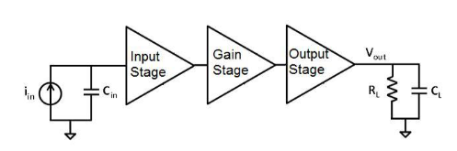

The initial design of the TIA was designed into 3 stages, being the Input, Gain and Output stage. The Input stage would be taking in the input current and combining it with the bias current

When it comes to the design procedure, I started with the initial current mirror setup knowing that to power up all the potential mosfets, the input current wouldn’t be enough in the input stage. Using the one external current source given to us, I decided that it would be for the best to use it to power up the MOSFETs and replicating it through current mirrors and cascoding while meeting the required specs for input and output resistance. Afterwards, I began planning for the gain stage by trying to find a way to maximize bandwidth while trying to increase the gain as much as possible. Finally, I wanted enough current to flow through the drain stage while also minimizing the gain. When it came to retrieving the width and length of the mosfets, I set my mosfet default to 0.5 um, while using the Gm/Id calculator to get a satisfactory Gm/Id value with a VDS to retrieve width. If the width didn't satisfy the specs that were needed for saturation, I modified the width until it did so. If there were ever a point that I maximized width, I would then alter L to try to raise the width/length ratio.

# Nominal Specifications and constraints

| **Name** of the spec. | Spec. corresponding to **your** design | **Performance** from your design @ 27oC |
| --- | --- | --- |
| Gain (ohm) | >100k | 444k |
| BW (MHz) | > 65MHz | 81Mhz |
| Input Impedance(ohm) | < 250 | 195 |
| Output Swing(V) | > 300mV | 320mV |
| Power(uW) | <500uW | 201.3uW |

Design constraints:

* Temperature Range
* One ideal current source in testbench from ground to bias pin in test bench
* No ideal elements in the design
* Body Effect on N-MOSFETs not sourced to ground
* 5 nm multiples for transistor sizes
* no DC value in biasing
* All substrate terminal should be connected to ground, all PFET substrate can be connected to source
* vdd value should be set to 1

# Choice of topology and Justification

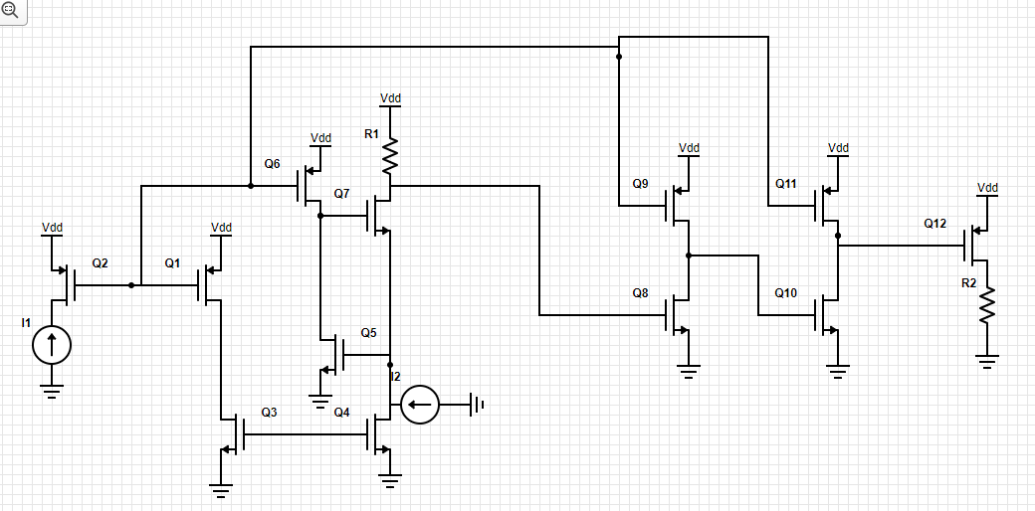

The transimpedance amplifier is composed of 3 stages, being the Input, Gain and Output stages. The initial Input stage is composed of a PMOS and NMOS current mirror to duplicate the bias current, as well as a Cascoded Common Gate Amplifier to minimize input resistance while also maximizing the resistance R1 that is used to calculate for transimpedance gain. The Gain Stage is divided into two common source active load amplifiers, which provide more gain than a resistor load while not being as temperature dependent. Since the active load is mirrored by the PMOS current mirror, the gain stage does not consume a lot of power, since the setup has a low 30uA bias current. The output stage utilizes a common drain amplifier with a resistive load to maximize bandwidth, and to minimize gain loss while also keeping a high current flowing through the drain amplfier. a NMOS is used in the drain region, since we assume that the output of the gain stage will be high enough so that we have to use a NMOS instead of the PMOS

# Test bench



| VDD | VSS | Cin | CL | RL | Bias | Input |
| --- | --- | --- | --- | --- | --- | --- |
| 1V | 0V | 1pF | 2pF | 10kΩ | 30uA | 0.7uA |

# Hand analysis Calculation

## The input stage

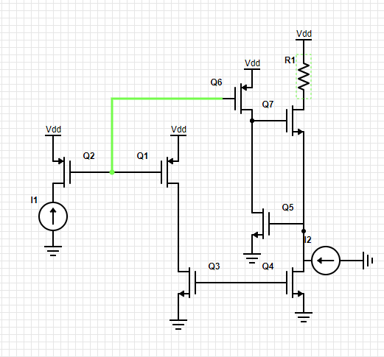

For the input stage, I used a Gm boosting Common Gate Amplifier setup to minimize the input impedance(this setup is directly referred from pages 23-24 of the lecture 5 slides). Q1 and Q2 act as a PMOS current mirror, while Q3 and Q4 are a NMOS current mirror. Considering Q6 is identical to Q1 and Q2 as a mirrored PMOS, the input impedance is given as $1/gm(1+A)$, for which A = Gm5ro4ro6 assuming that R1 << r05. The transimpedance gain is the gain of the total circuit multiplied by R1.

## The Gain stage

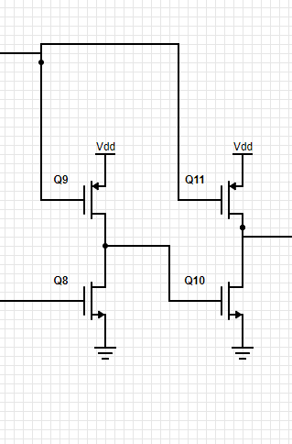

The gain stage is divided into two Active Load common source stages. Considering the first gain stage(Q8 and Q9),

the gain earned is $gm8/(go8 + go9)$, and the second gain stage(Q10 and Q11) is $gm10/(go10 + go11$), then the total gain earned in the gain stage is $(gm8gm10/((go8+go9)(go10+go11))$

## Output buffer stage

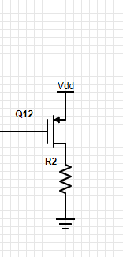

The drain stage is a resistive load common drain, and Vout is $gm12 * (Vin - Vout) * R2$, so Vout(1 + gmR2) = gmR2 * Vin, so Vout/Vin, or gain is equal to (1+gmR2)/gmR2. Furthermore, Vout < VDD, and Vout = Vs, and assuming saturation status, output swing is the bound in which Vds > Vgs - Vth, which has to be higher than 300mV.

# Results

Here you will have to report the numeric values.

## Performace at different temperature

| Spec. (Units) | 0o C | 27o C | 100o C |
| --- | --- | --- | --- |
| Transimpedance gain (ohm) | 471.599k | 444.707k | 334.098k |
| BW (MHz) | 84.5354 | 81.3706 | 72.5478 |
| Input Impedance(ohm) | 218.097 | 195.746 | 181.391 |
| Output Swing(mV)  @10MHz | 347.978 | 341.26 | 305.617 |
| Output  Swing(V)  @100Hz | 346.87 | 338.38 | 304.27 |

## MC yields at different temperature

|  | TestBench | Results | Yield |
| --- | --- | --- | --- |
| 0o C |  |  | 100% |
| 27o C |  |  | 100% |
| 100o C |  |  | 99.5% |

## Area Calculation

| Component | Total Width (um) | Length (um) | Multiplier | Area(um2) |
| --- | --- | --- | --- | --- |
| Q1 | 8 | 0.5 | 1 | 4 |
| Q2 | 8 | 0.5 | 1 | 4 |
| Q3 | 6 | 0.5 | 1 | 3 |
| Q4 | 6 | 0.5 | 1 | 3 |
| Q5 | 29.8 | 1 | 1 | 29.8 |
| Q6 | 8 | 0.5 | 1 | 4 |
| Q7 | 47.5 | 1 | 1 | 47.5 |
| Q8 | 0.54 | 0.5 | 1 | 0.27 |
| Q9 | 8 | 0.5 | 1 | 4 |
| Q10 | 4.2 | 0.5 | 1 | 2.1 |
| Q11 | 8 | 0.5 | 1 | 4 |
| Q12 | 20 | 0.5 | 1 | 10 |
| R1 | 1.5 | 45 | 1 | 67.5 |
| R2 | 1.5 | 30 | 1 | 45 |

Total area = 271.3012 um2

## Power consumption calculation

I = 201.3uA, VDD = 1V, so power consumption = 201.3uW

## FoM calculation

By now you should have all the values to calculate the FoM using the given formula in the handout. Pay attention to the units and the order of magnitude. FoMs for three temperatures are to be reported.

| 0o C | 27o C | 100o C |
| --- | --- | --- |
| 3.37258304*1010 | 4.15992576*1010 | 3.93958772*1010 |

| Power | 0o C | 27o C | 100o C |
| --- | --- | --- | --- |
| Gate(uW) | 102.7 uW | 97.545 uW | 93.453 uW |
| Source(uW) | 60 uW | 60 uW | 60 uW |
| Drain(uW) | 28.06 uW | 28.06 uW | 27.8 uW |
| Total(uW) | 203.55 uW | 201.356uW | 195.533uW |

# Discussions

The main challenge that I faced when it comes to designing the TIA was the output swing, and how to set the drain stage so that I could meet the specific specs while trying to keep the input at the drain stage as high as possible. Maximizing the width of the mosfet in the drain stage would increase bandwidth, but would subsequently lower the voltage swing. Another challenge I had was increasing the gain of the common source gain stage will also trying to keep bandwidth above 65 MHz, since it was a rigorous task to reach the bandwidth specs and trans-impedance gain simultaneously.

# Conclusion

The overall design of the TIA met all of the requirements even with the Monte Carlo analysis. Overall, this design taught me a lot about how to design an effective TIA, and the improvements I can make on it. I feel like I could have gotten a better output swing if I had forced more current through the drain stage, while also making sure that the output voltage wouldn’t be as low as it was in the design. This would lead to a more consistent output swing without any dents as shown in the graphs.

##### Appendix

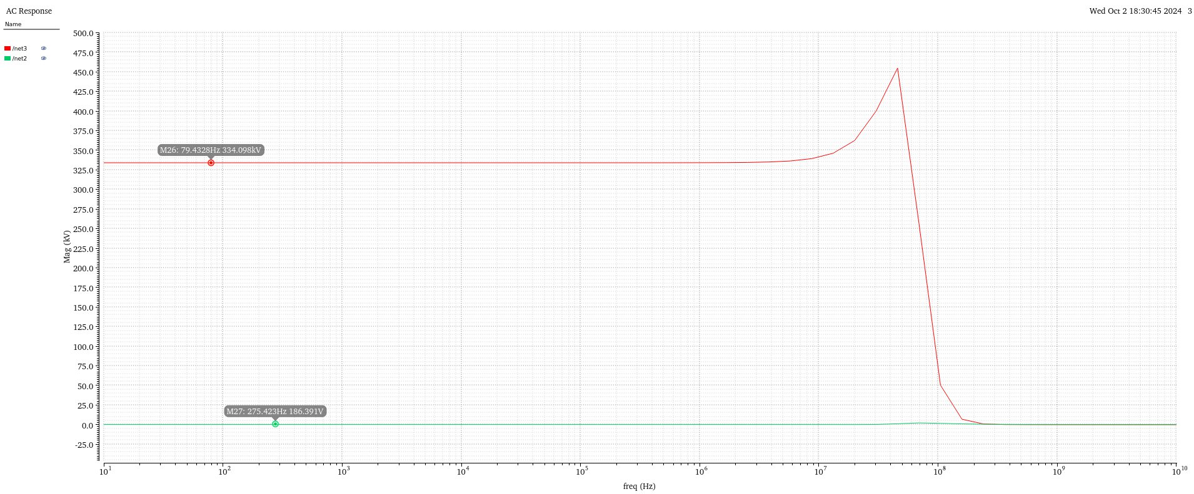

Input Impedance(lower marker) and Transconducdance gain(higher marker) at 100o C

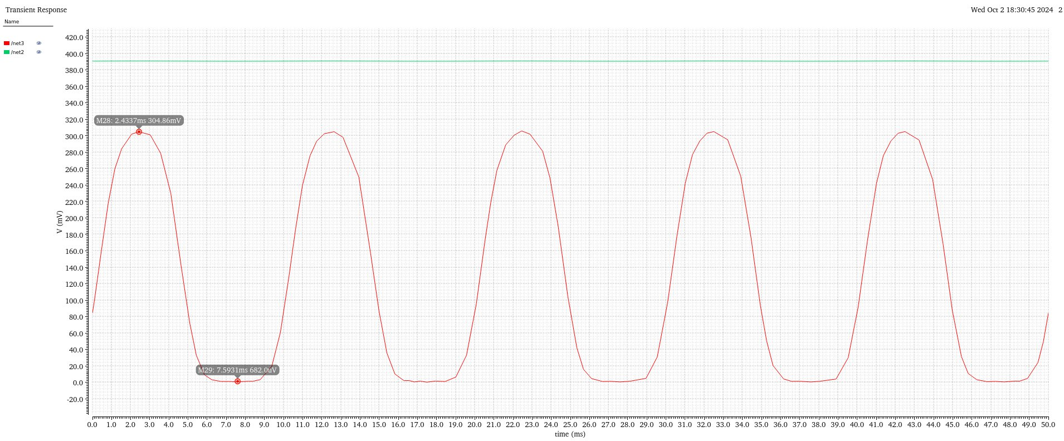

Output Swing(100 Hz) at 100o C

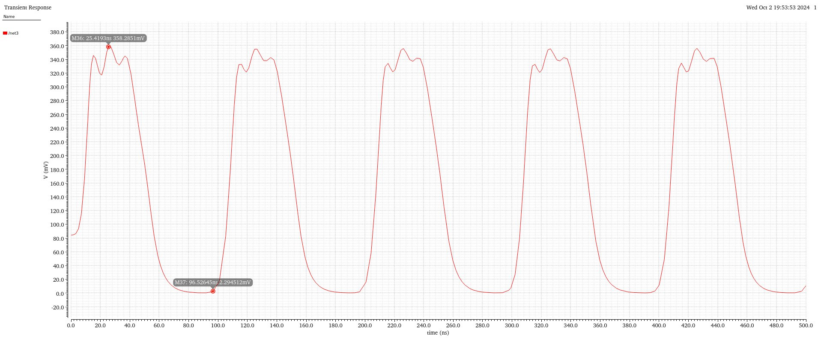

Output Swing(10 MHz) at 100o C

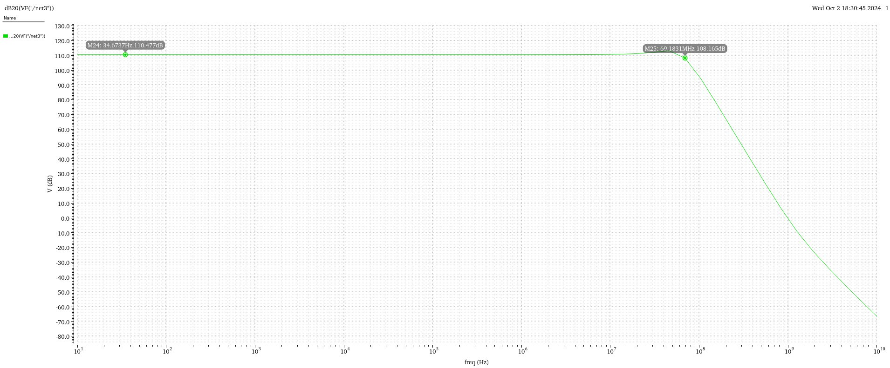

DB gain at 100o C

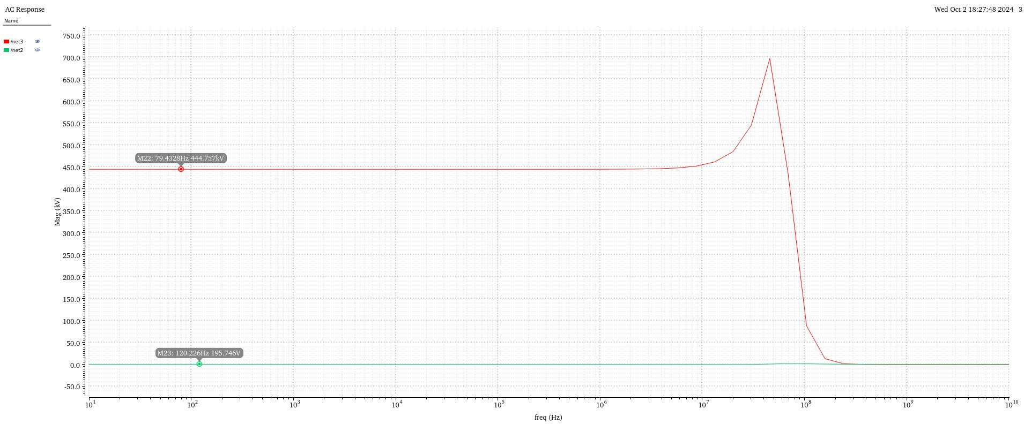

Input Impedance(lower marker) and Transconducdance gain(higher marker) at 27o C

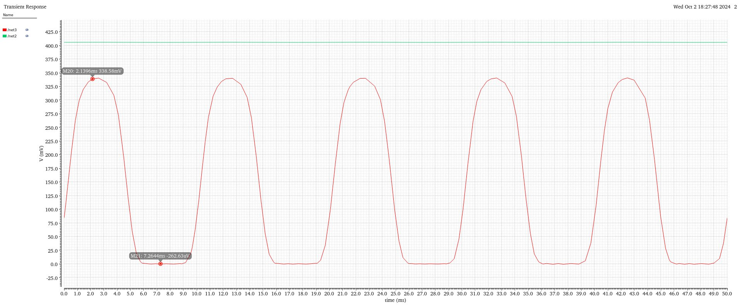

Output Swing(100 Hz) at 27o C

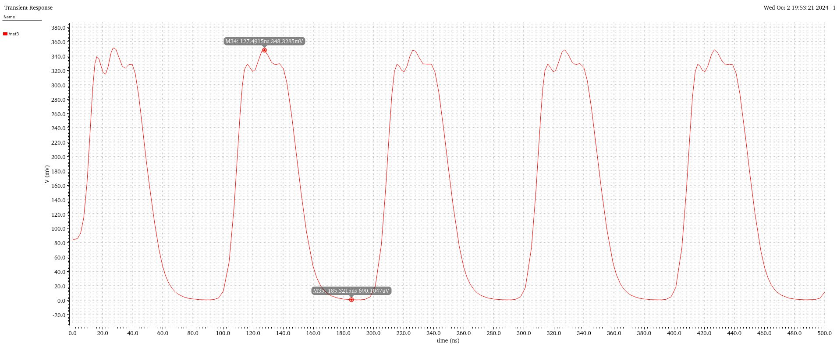

Output Swing(10 MHz) at 27o C

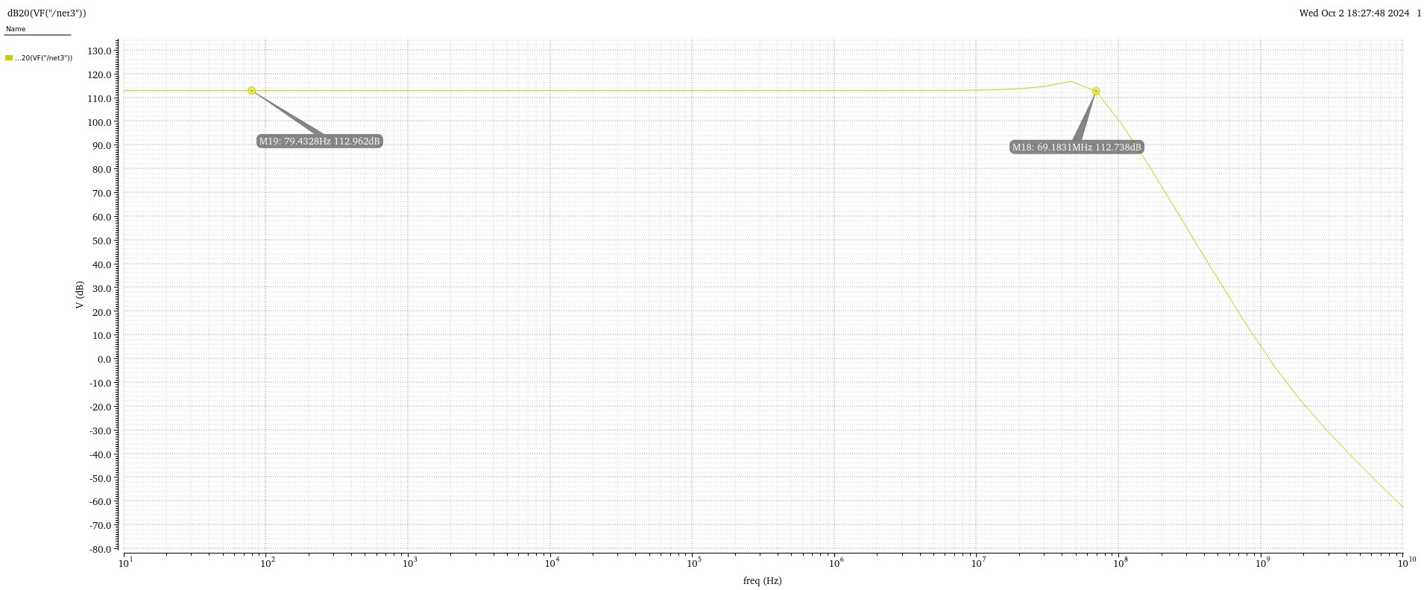

DB gain at at 27o C

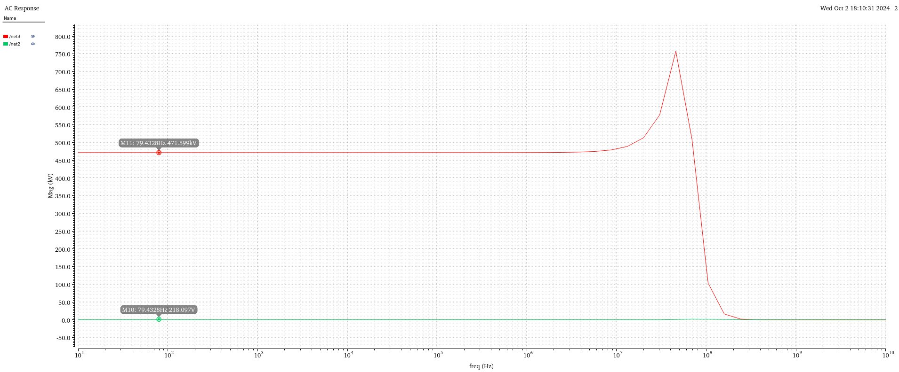

Input Impedance(lower marker) and Transconducdance gain(higher marker) at 0o C

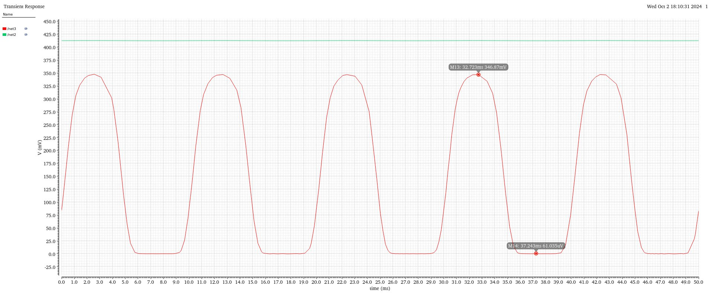

Output Swing(100 Hz) at 0o C

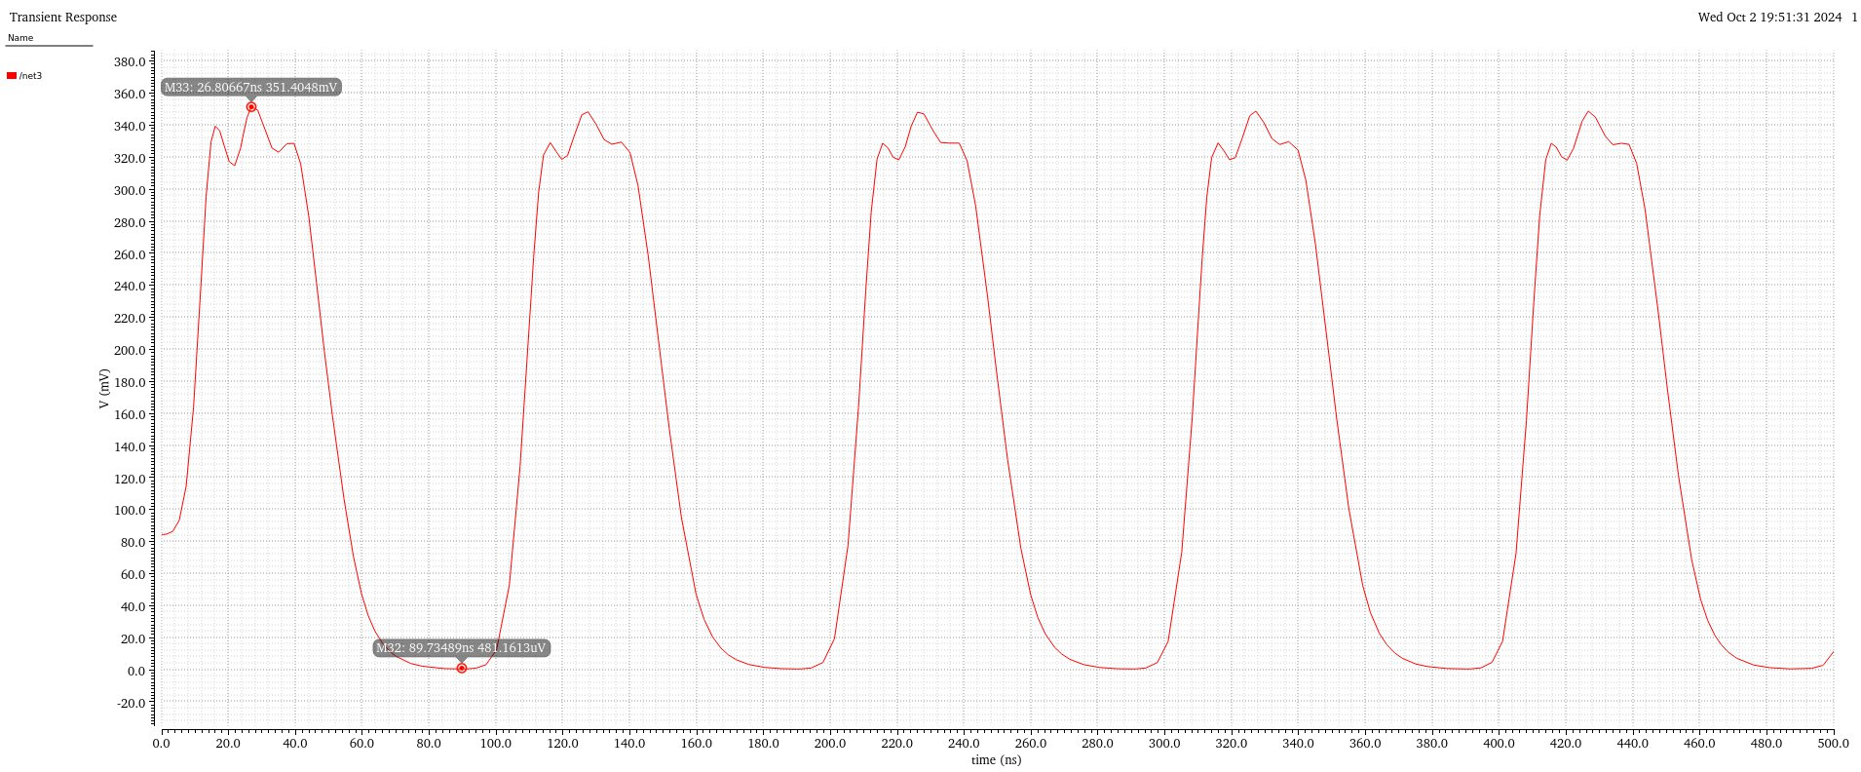

Output Swing(10MHz) at 0o C

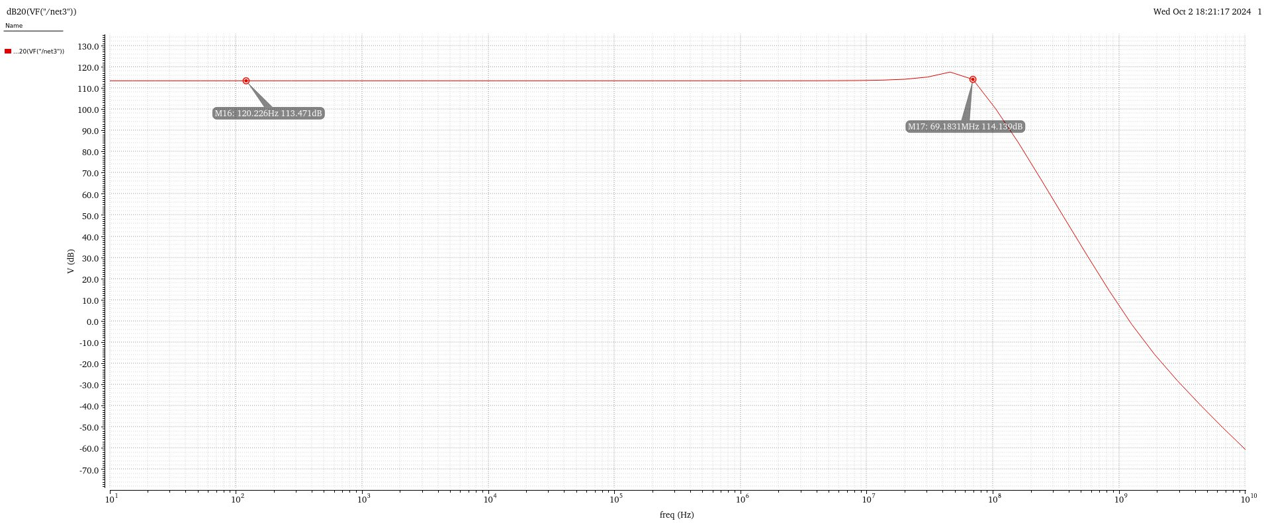

DB gain at 0o C

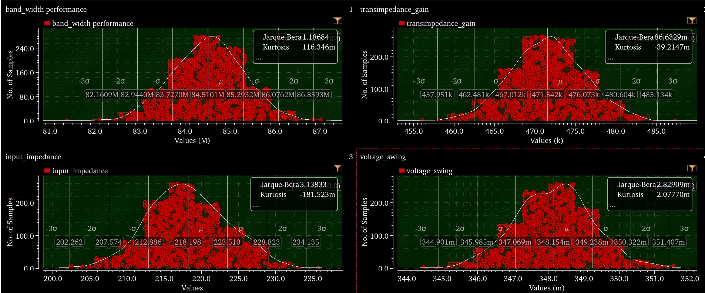

Monte Carlo Results at 0o C

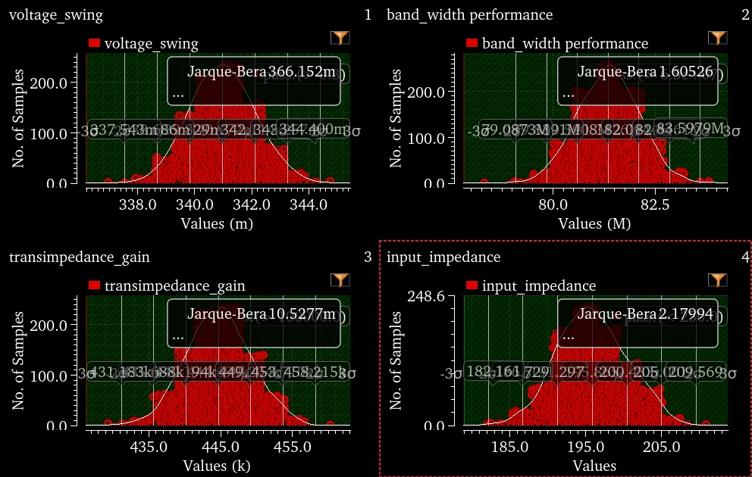

Monte Carlo Results at 27o C

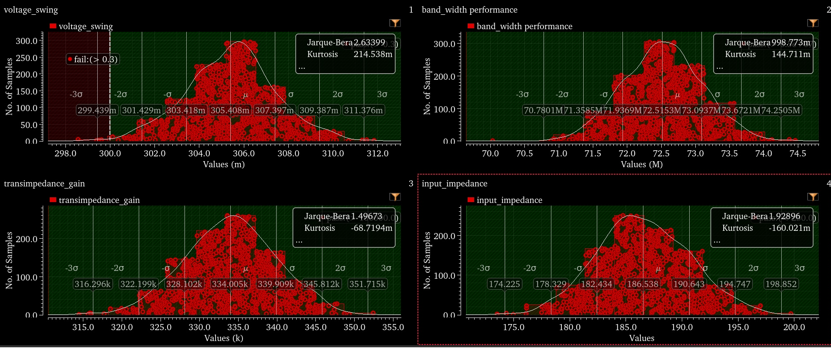

Monte Carlo Results at 100o C